CREATE JAVA APPLICATION

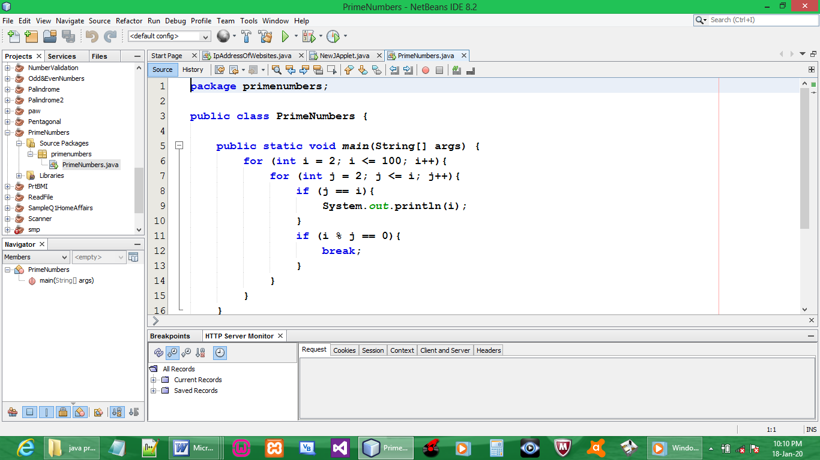

CODE:

package primenumbers;

public class PrimeNumbers {

public static void main(String[] args) {
for (int i = 2; i <= 100; i++){
for (int j = 2; j <= i; j++){
if (j == i){
System.out.println(i);
}
if (i % j == 0){
break;
}
}
}
}

}

OUTPUT:

